Task 1 — Configure Cross-Region VPC Peering
Task 1 — Configure Cross-Region VPC Peering
We will create:
- Mumbai VPC → Region ap-south-1
- Hyderabad VPC → Region ap-south-2
- VPC Peering Connection
- Routes in both route tables
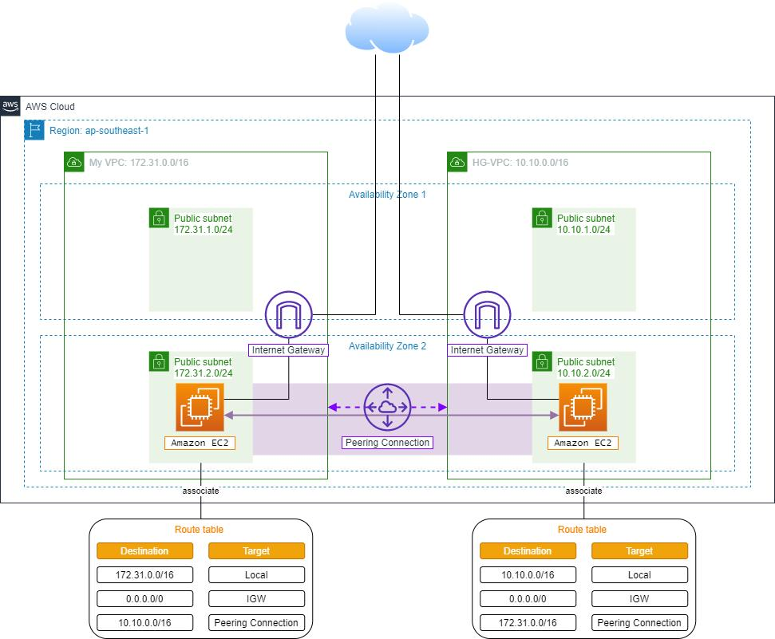
Step 1 — Create Mumbai VPC
1.1 Switch to Mumbai Region
Top-right region selector → Asia Pacific (Mumbai) – ap-south-1

1.2 Create VPC
Go to VPC → Your VPCs → Create VPC
Choose VPC only
Fill:
Field | Value
Name | Mumbai-VPC
IPv4 CIDR | 20.0.0.0/16
Tenancy | Default
Click Create VPC.
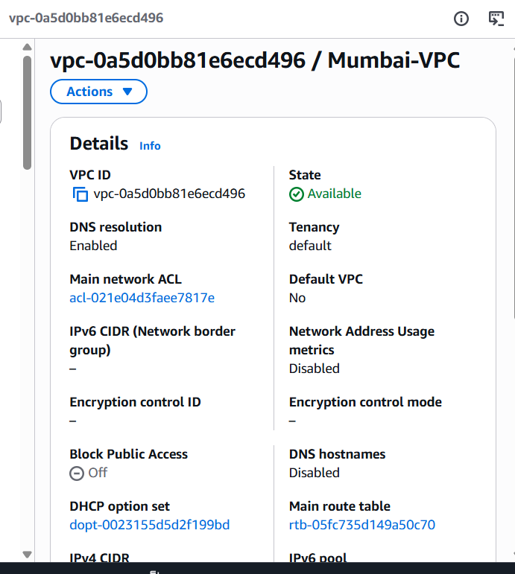

Step 2 — Create Hyderabad VPC
2.1 Switch Region
Select Asia Pacific (Hyderabad) – ap-south-2

2.2 Create VPC
Go to VPC → Your VPCs → Create VPC
Fill:
Field | Value
Name | Hyderabad-VPC
IPv4 CIDR | 30.0.0.0/16
Tenancy | Default
Click Create VPC.
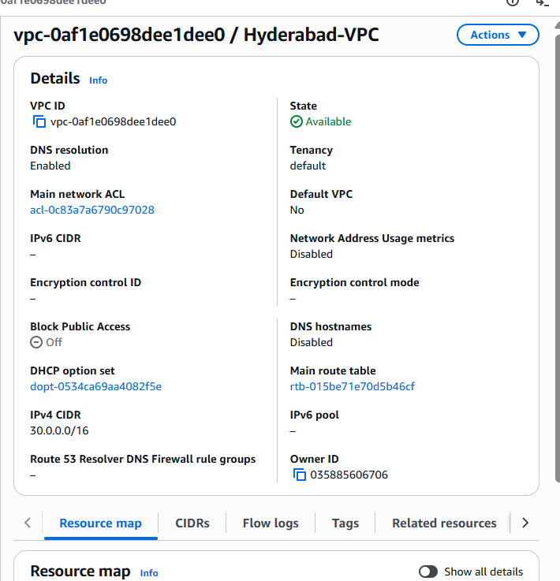
Step 3 — Create Peering Connection
3.1 Go to Mumbai Region
Switch back to Mumbai (ap-south-1).
Go to VPC → Peering Connections → Create Peering Connection

3.2 Fill Peering Details
Use these values:
Field | Value
Name | Mumbai-Hyd-Peering
Requester VPC | Mumbai-VPC
Account | My account
Region | Another region
Accepter Region | ap-south-2
Accepter VPC | Hyderabad-VPC
Click Create peering connection.
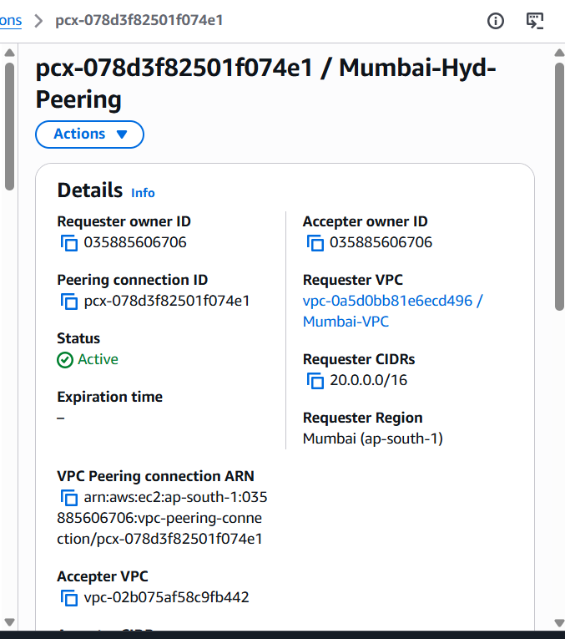
Step 4 — Accept Peering Request
4.1 Switch to Hyderabad
Go to VPC → Peering Connections
You will see a request in Pending Acceptance.

4.2 Accept
- Select the request
- Click Actions → Accept request
Status should become:
Active
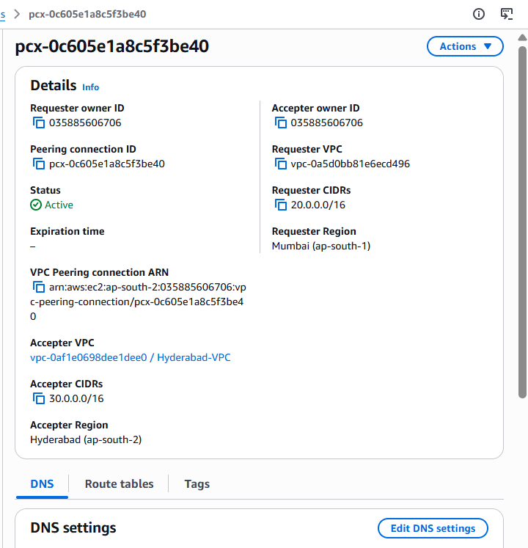

Step 5 — Add Route in Mumbai
5.1 Open Route Tables
In Mumbai region:
VPC → Route Tables
Select the route table associated with Mumbai-VPC.

5.2 Edit Routes
- Click Actions → Edit routes
- Click Add route
Enter:
Destination | Target
30.0.0.0/16 | Select Peering Connection
Choose the peering connection.
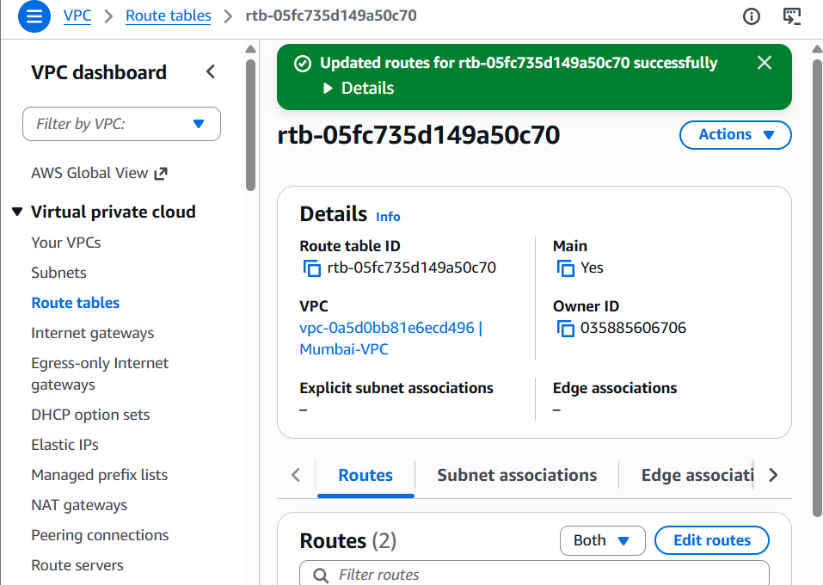
Click Save changes.

Step 6 — Add Route in Hyderabad
In Hyderabad region:
VPC → Route Tables → select Hyderabad route table → Actions → Edit routes → Add route
Enter:
Destination | Target
20.0.0.0/16 | Same Peering Connection
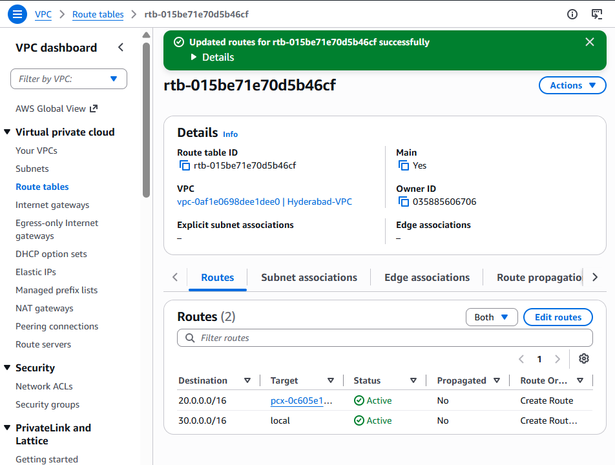
Click Save changes.
Step 7 — Verify
Go to Peering Connections and confirm:
Peering Status: Active
Mumbai route added: 30.0.0.0/16
Hyderabad route added: 20.0.0.0/16

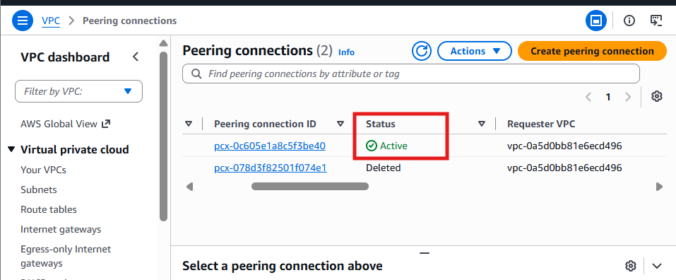

Task 2.Purchase one domain from GoDaddy.
I have purchased Domain from GoDaddy
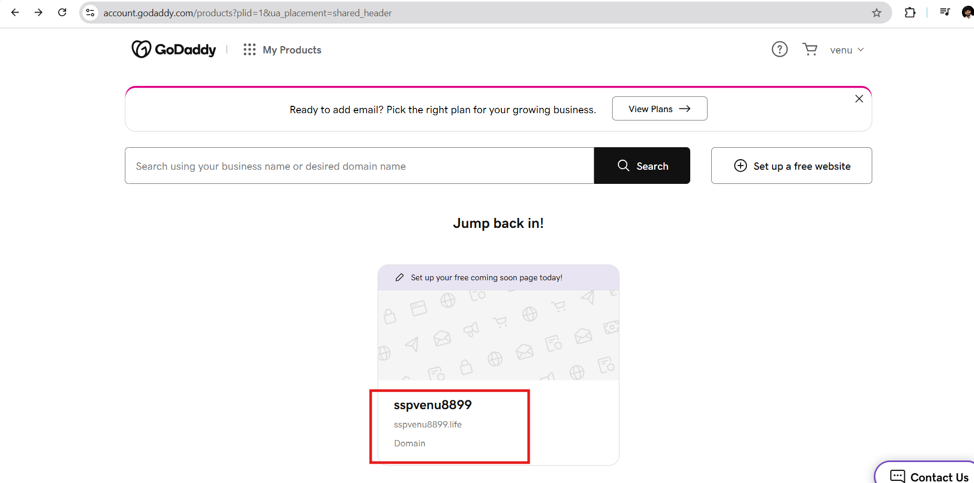Task 3 — Create S3 Bucket and Upload Website
We will:
- Create an S3 bucket
- Upload index.html
- Enable static website hosting
- Make the website publicly accessible
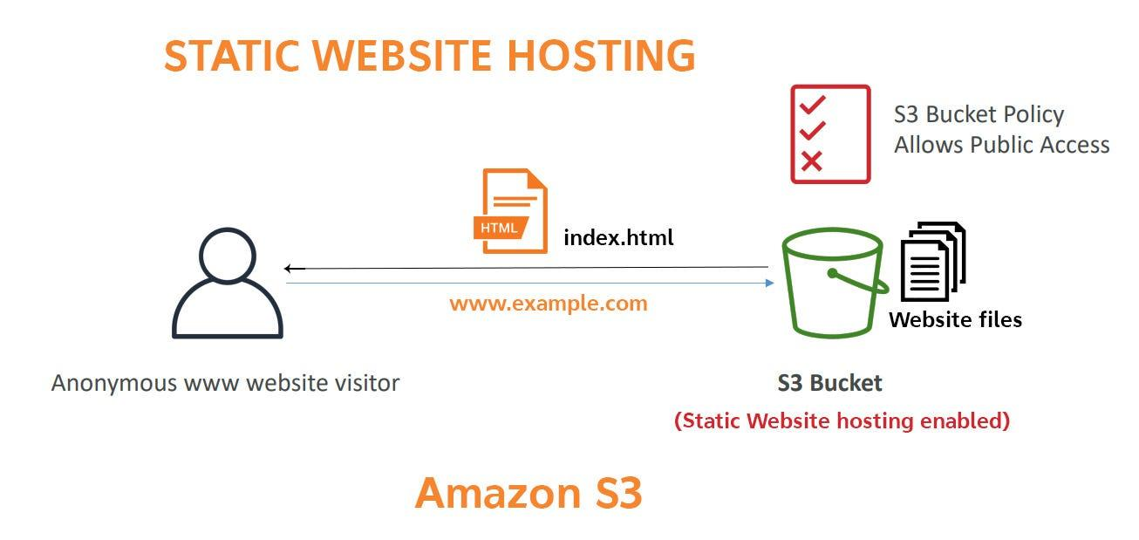
Step 3.1 — Open S3
- In AWS Console, search S3
- Open Amazon S3
- Click Create bucket

Step 3.2 — Create Bucket
Fill these values:
Field | Value
Bucket name | venu-static-demo-2026
AWS Region | ap-south-1 (Mumbai)
Object Ownership | ACLs disabled (recommended)
Block all public access | Uncheck this option
When you uncheck it, tick:
I acknowledge that the current settings might result in this bucket and the objects within becoming public
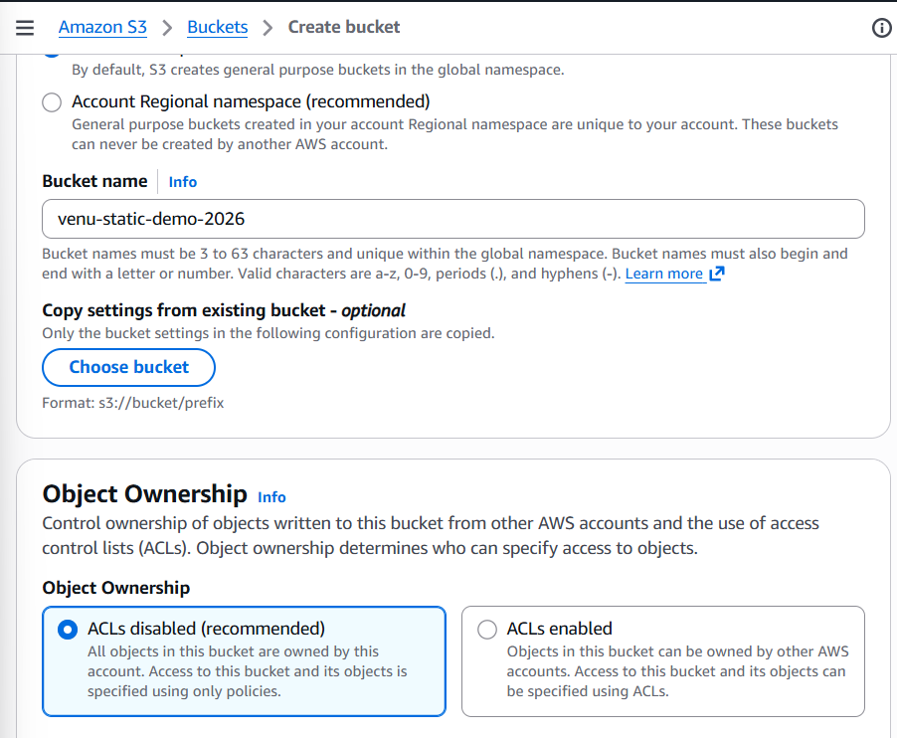
Click Create bucket.
Step 3.3 — Open the Bucket
Click the bucket name:
venu-static-demo-2026
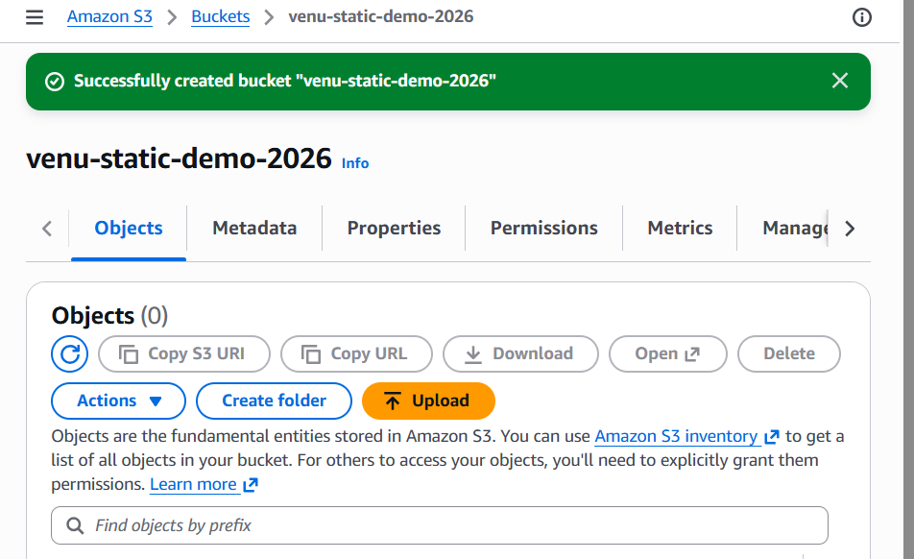
Step 3.4 — Upload index.html
- Click Upload
- Click Add files
- Select your index.html
- Click Upload
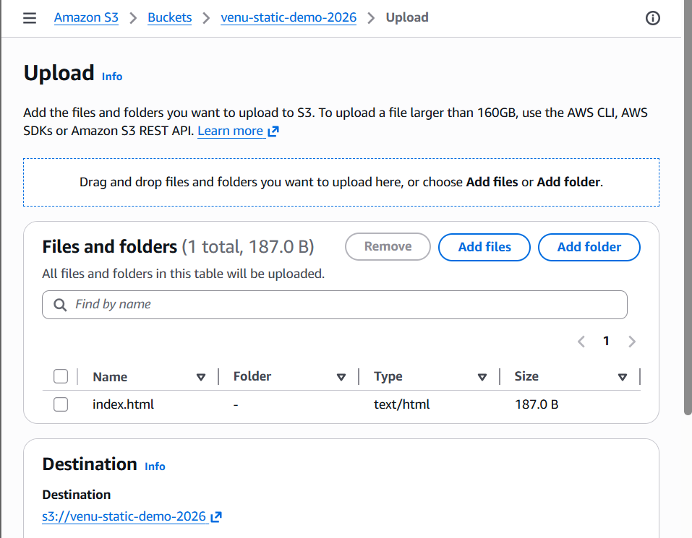
Step 3.5 — Enable Static Website Hosting
Go to the Properties tab.
Scroll down to Static website hosting and click Edit.

Select:
- Enable
- Hosting type: Host a static website
- Index document: index.html
Click Save changes.
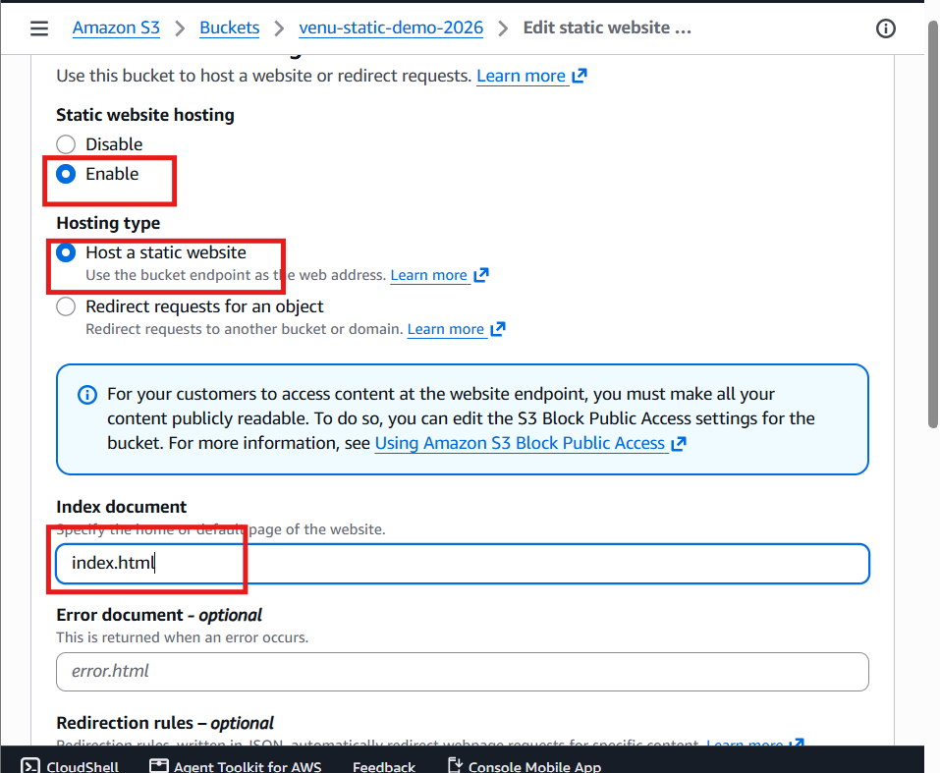
Step 3.6 — Add Bucket Policy
Go to the Permissions tab.
Scroll to Bucket policy → click Edit.
Paste this policy:
{
"Version":"2012-10-17",
"Statement":[{
"Sid":"PublicRead",
"Effect":"Allow",
"Principal":"*",
"Action":["s3:GetObject"],
"Resource":["arn:aws:s3:::venu-static-demo-2026/*"]
}]
}
Click Save changes.
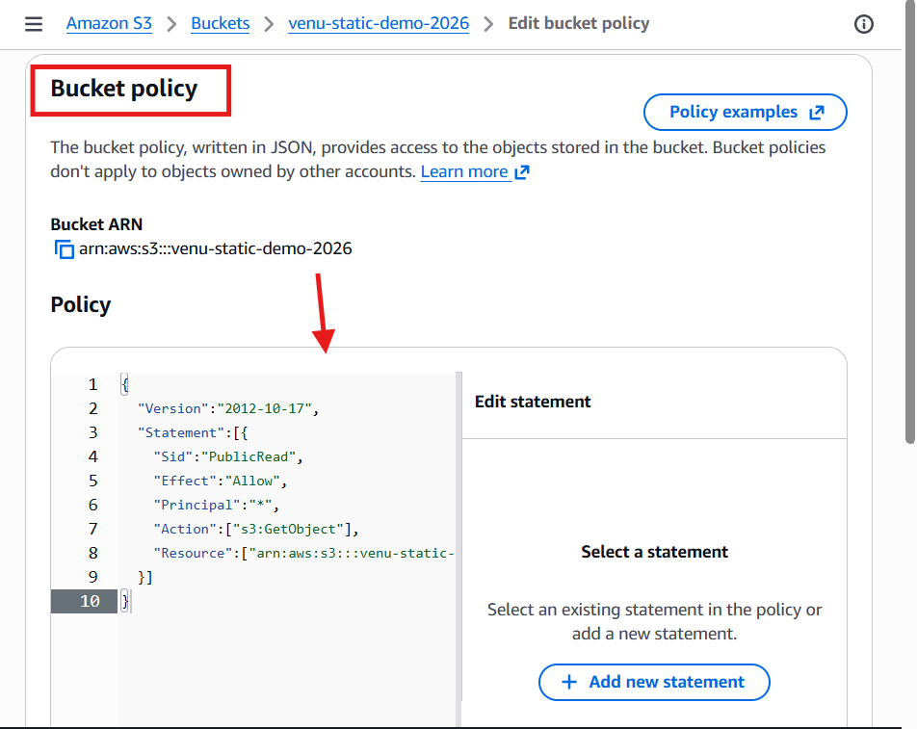
Step 3.7 — Copy Website Endpoint
Go back to Properties.
At the bottom, under Static website hosting, copy the Bucket website endpoint.
It will look like:
http://venu-static-demo-2026.s3-website.ap-south-1.amazonaws.com
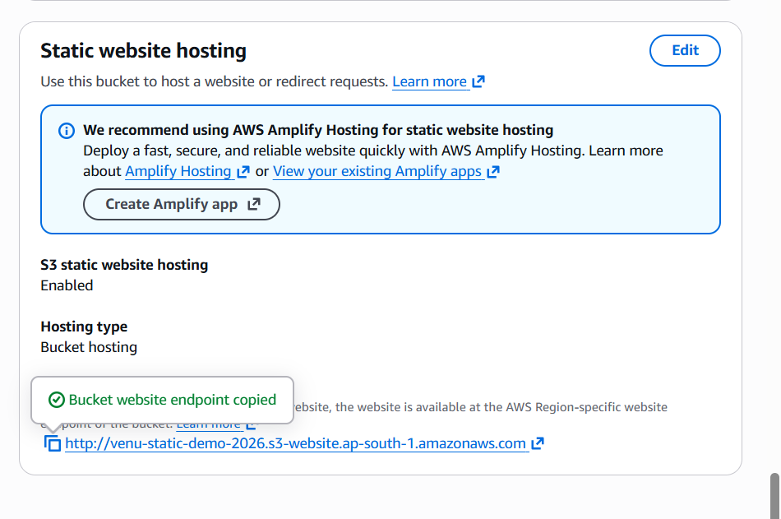
Step 3.8 — Test the Website
Open the endpoint URL in a browser.
You should see:
venu-static-demo-2026.s3-website.ap-south-1.amazonaws.com
Welcome to Venu AWS Static Website
This site is hosted using Amazon S3 Static Website Hosting.
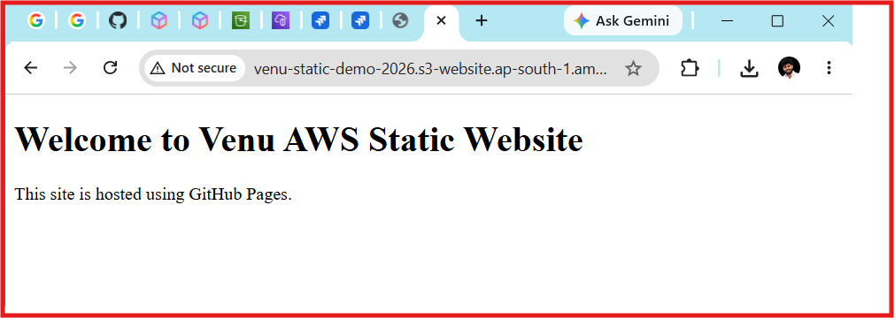
Task 4 — Create CloudFront + SSL
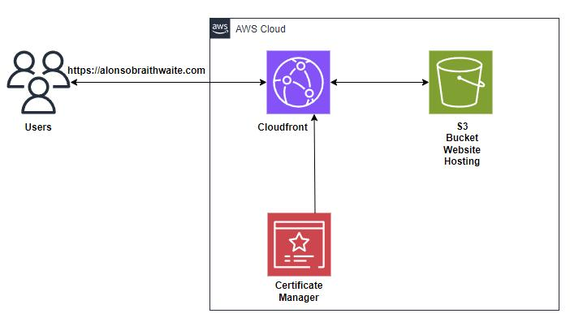
Step 4.1 — Open CloudFront
- In AWS Console, search CloudFront
- Open Amazon CloudFront
- Click Create distribution

Step 4.2 — Configure Origin
Under Origin domain, select your S3 website endpoint.
⚠️ Important: choose the endpoint that looks like:
venu-static-demo-2026.s3-website.ap-south-1.amazonaws.com
Do not choose the bucket name only.
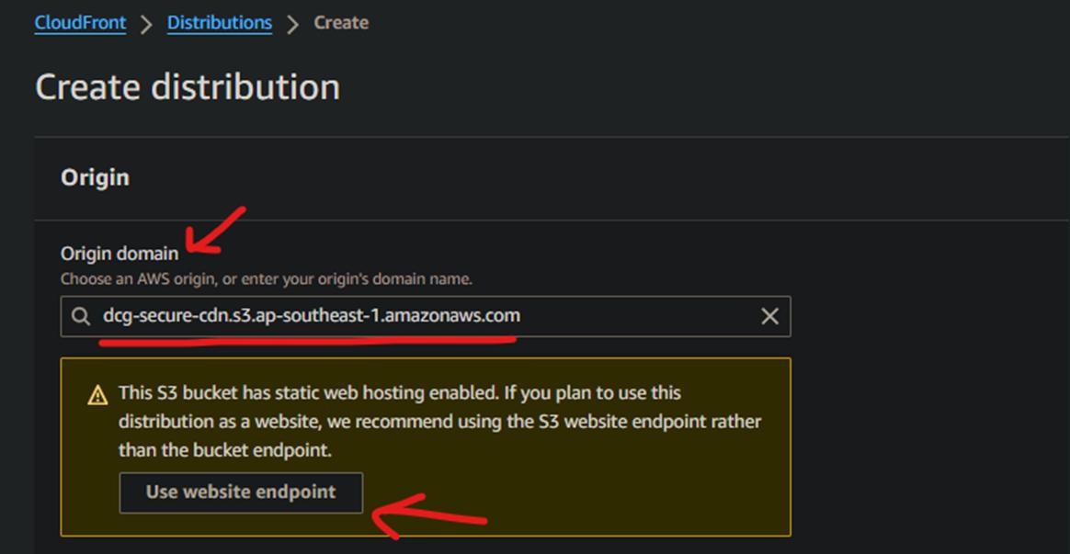
Step 4.3 — Viewer Settings
Set:
- Viewer protocol policy: Redirect HTTP to HTTPS
- Allowed HTTP methods: GET, HEAD
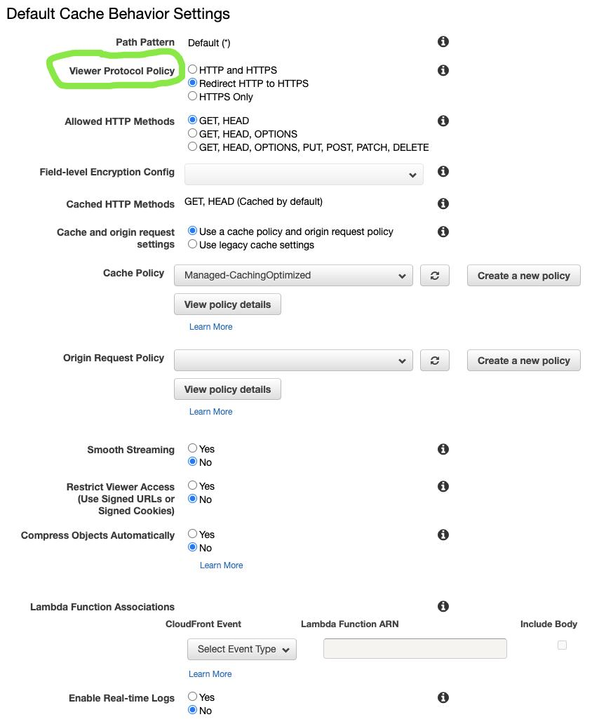
Step 4.4 — Leave SSL for Now
Because we are using the default CloudFront domain, leave:
- Alternate domain name (CNAME): empty
- Custom SSL certificate: default CloudFront certificate
We’ll still get HTTPS automatically.
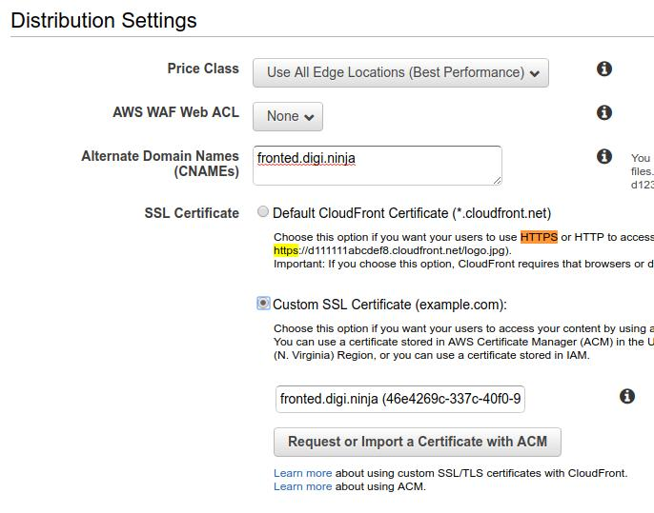
Step 4.5 — Create Distribution
Click Create distribution.
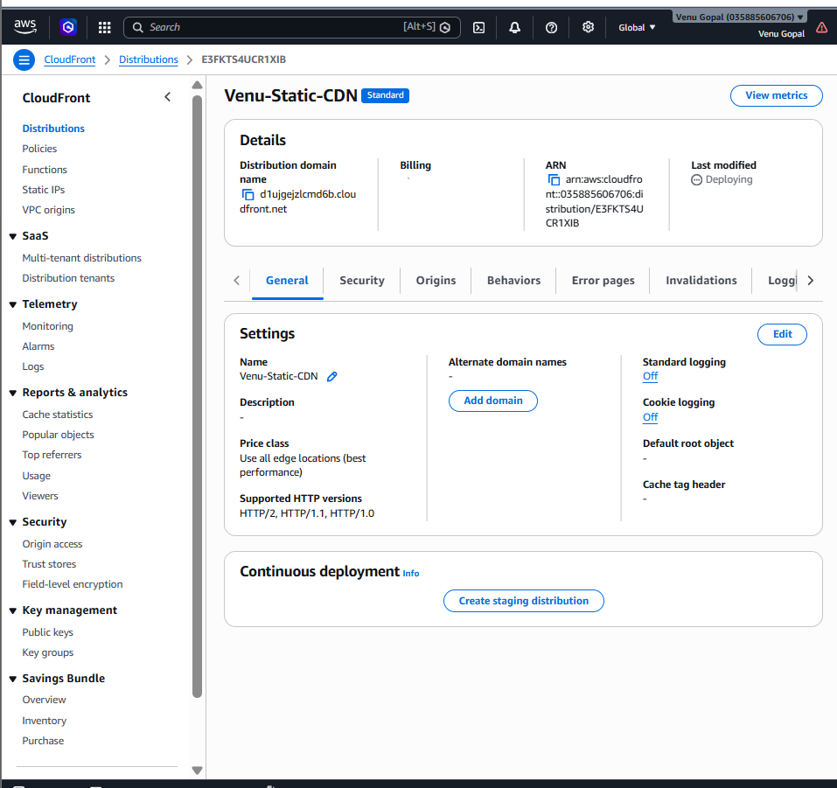
CloudFront deployment will take 5–10 minutes.
Step 4.6 — Copy CloudFront Domain
After deployment, copy the Distribution domain name.
It will look like:
d123abcdxyz.cloudfront.net
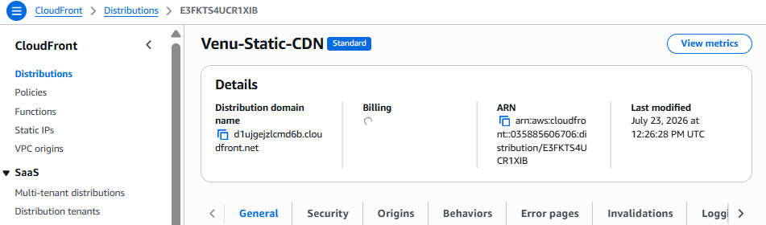
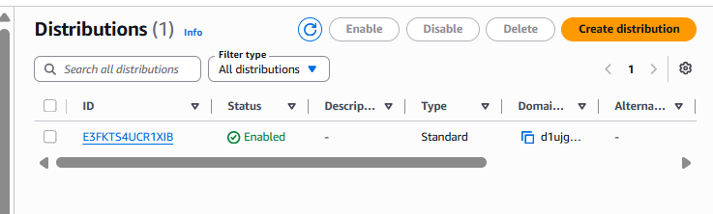
Step 4.7 — Test HTTPS
Open:
https://d123abcdxyz.cloudfront.net
You should see the same website, now served through HTTPS.

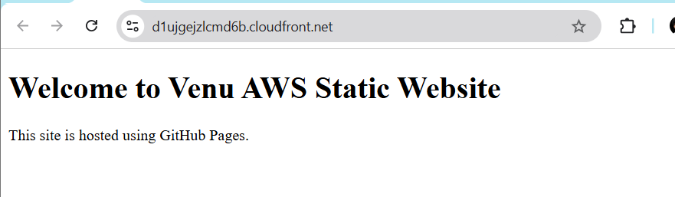

Task 5 — Update index.html and verify the updated content through CloudFront
We’ll do it step by step.
Step 5.1 — Open the S3 bucket
Go to:
S3 → venu-static-demo-2026 → Objects
You will see:
- index.html
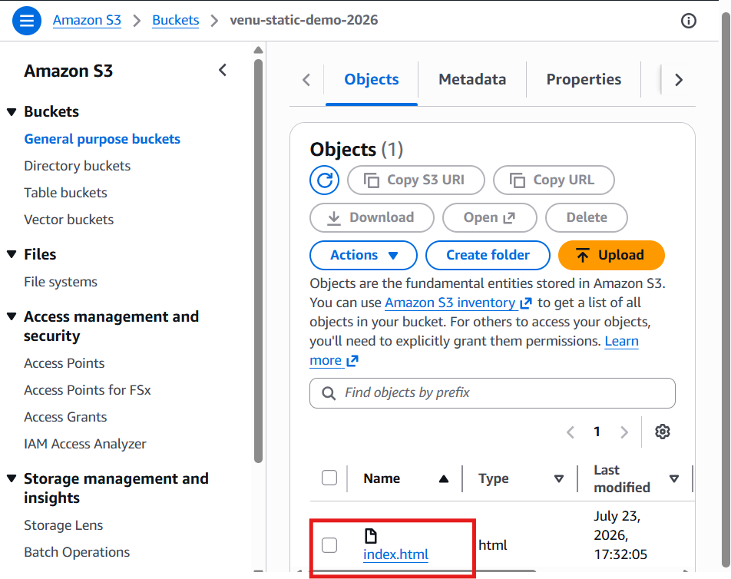
Step 5.2 — Download the current file
- Select index.html
- Click Download
Step 5.3 — Edit the file
Open index.html in Notepad and replace the content with:
<!DOCTYPE html>
<html>
<head>
<title>Venu AWS Demo</title>
</head>
<body>
<h1>Welcome to Venu AWS Static Website - Updated</h1>
<p>This website is hosted on Amazon S3 and delivered through CloudFront CDN.</p>
<p>Update Time: July 23, 2026</p>
</body>
</html>
Save the file.
Step 5.4 — Upload the updated file
Back in S3:
- Click Upload
- Add files → select the updated index.html
- Click Upload
When prompted, choose Replace existing object.
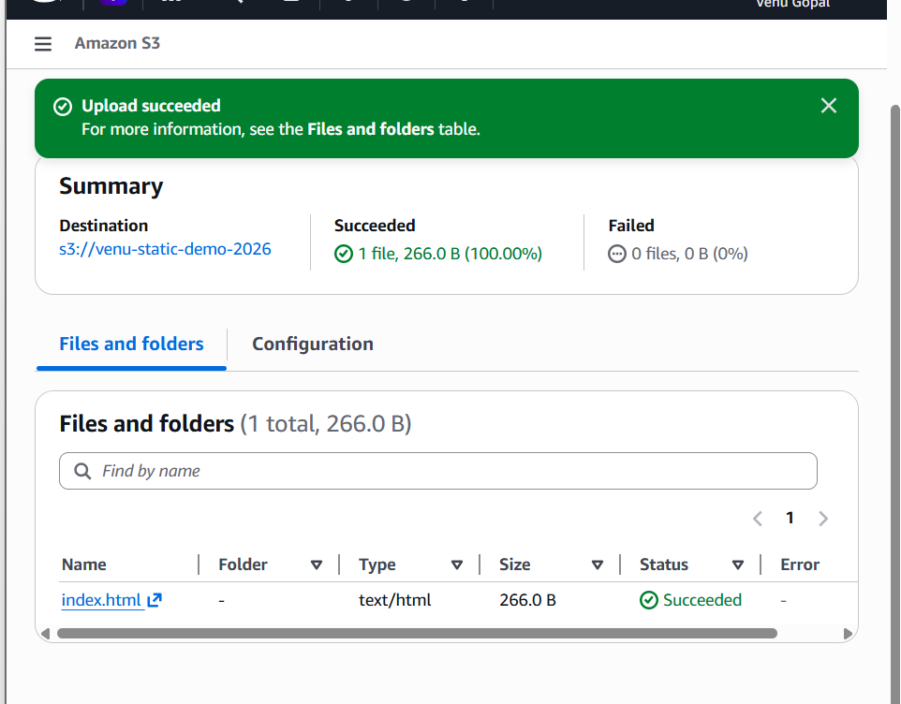
Step 5.5 — Create CloudFront invalidation
Go to:
CloudFront → Venu-Static-CDN → Invalidations
- Click Create invalidation
- Enter:
/*
- Click Create invalidation
Wait until the status becomes Completed.
Step 5.6 — Verify the updated website
Open your CloudFront URL:
🔗 https://d1ujgejzlcmd6b.cloudfront.net
You should now see:
- Welcome to Venu AWS Static Website - Updated
- This website is hosted on Amazon S3 and delivered through CloudFront CDN.
- Update Time: July 23, 2026
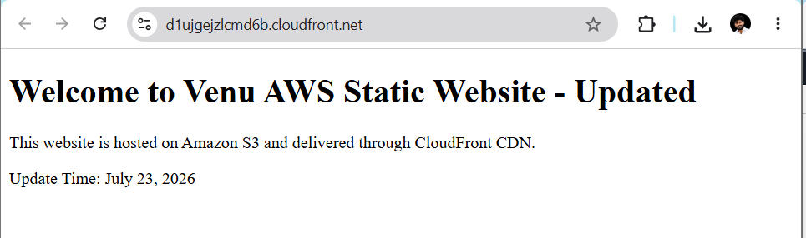

6. Create a Route 53 hosted zone and map the domain with the CDN.
Step 1 — Open Route 53
- In AWS Console, search Route 53
- Open Amazon Route 53

Step 2 — Go to Hosted Zones
In the left menu, click:
Hosted zones

Step 3 — Create Hosted Zone
Click:
Create hosted zone

Step 4 — Enter Domain Name
Fill these values:
Field | Value
Domain name | venu-static-demo.com
Type | Public hosted zone
Description | Practice hosted zone for CloudFront mapping
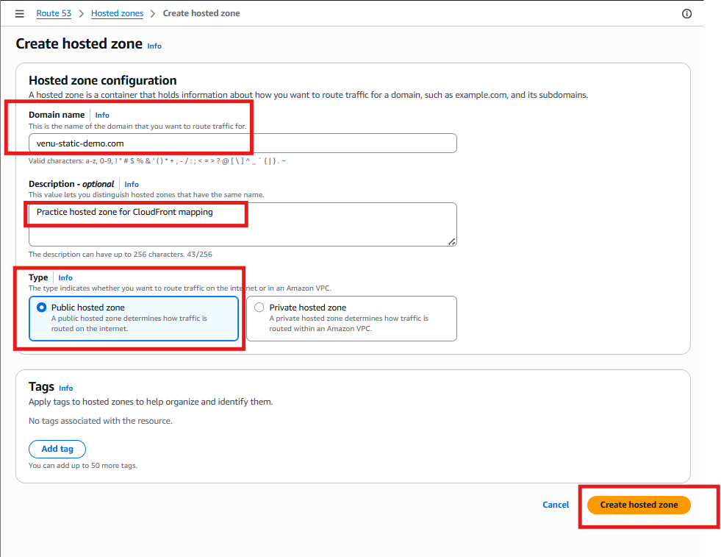
Click Create hosted zone.
Step 5 — Verify Hosted Zone
You will see a new hosted zone:
venu-static-demo.com
and some default records:
- NS record
- SOA record
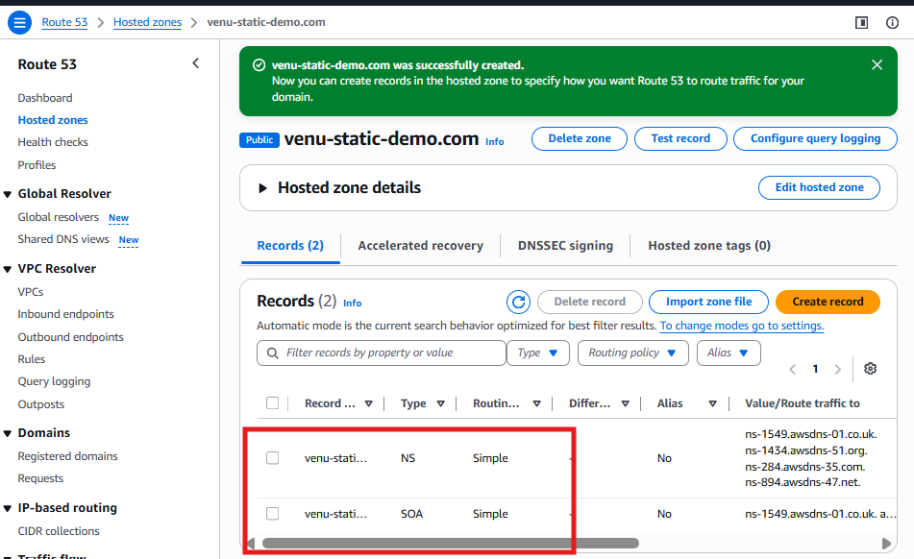
Note: Route 53 Hosted Zone and CDN Mapping (Practice Setup)
A public hosted zone named venu-static-demo.com was created in Amazon Route 53 for practice purposes. An attempt was made to configure an Alias record pointing to the CloudFront distribution d1ujgejzlcmd6b.cloudfront.net.
Since the domain was not purchased from GoDaddy (or any domain registrar), the Route 53 name servers could not be associated with a registered domain. As a result, public DNS resolution was not available and a working custom domain could not be configured.
The website was successfully accessed using the CloudFront HTTPS URL:
https://d1ujgejzlcmd6b.cloudfront.net
This setup was used to demonstrate the Route 53 hosted zone creation process and the CloudFront integration workflow without purchasing a domain.

Task 6– Create a Route 53 Hosted Zone and Map the Domain with CloudFront CDN
Step 1: Create a Hosted Zone
- Login to the AWS Console.
- Search for Route 53.
- Click Hosted zones.
- Click Create hosted zone.
- Enter:
Field | Value
Domain Name | sspvenu8899.life
Type | Public Hosted Zone
- Click Create hosted zone.
AWS will create:
- NS (Name Server) Record
- SOA Record
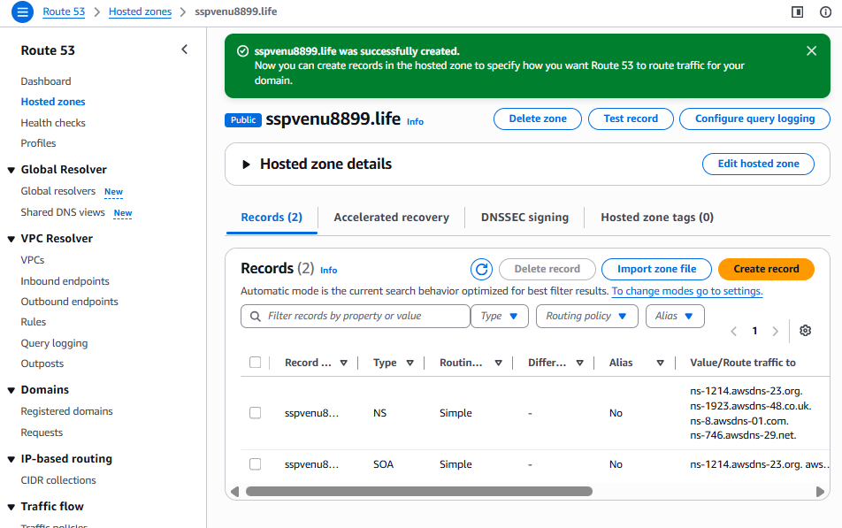

Step 2: Copy the Name Servers
Example:
ns-123.awsdns-10.com
ns-456.awsdns-20.net
ns-789.awsdns-30.org
ns-321.awsdns-40.co.uk
Copy all 4 NS records.

Step 3: Update GoDaddy Name Servers
- Login to GoDaddy.
- Go to My Products.
- Click DNS next to your domain.
- Under Nameservers, click Change.
- Select I'll use my own nameservers.
- Replace GoDaddy's default nameservers with the 4 AWS NS records.
- Save.
Wait 10–60 minutes (sometimes up to 24 hours) for DNS propagation.
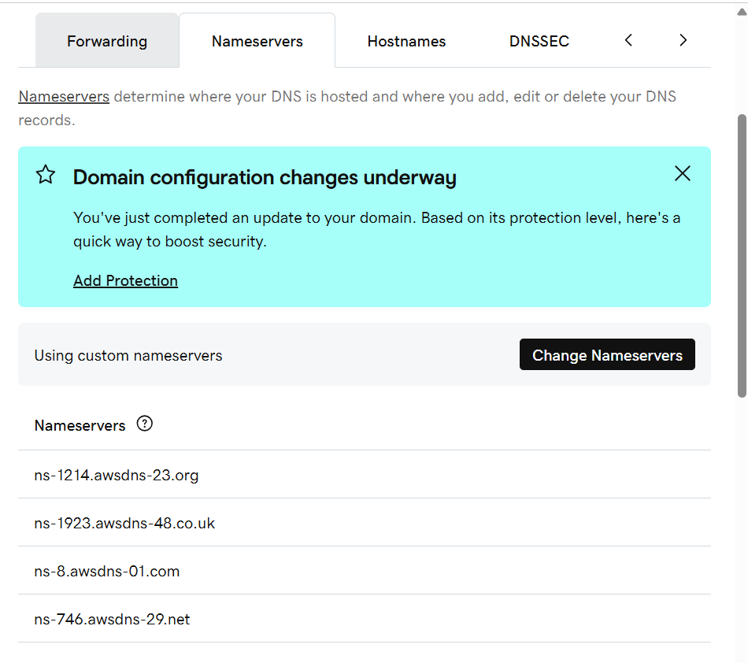

Step 4: Create Alias Record for CloudFront
In the Route 53 Hosted Zone:
Click Create Record
Root Domain
Field | Value
Record Name | (leave blank)
Record Type | A
Alias | Yes
Route Traffic To | Alias to CloudFront Distribution
Select Distribution | Your CloudFront Distribution
Click Create Records
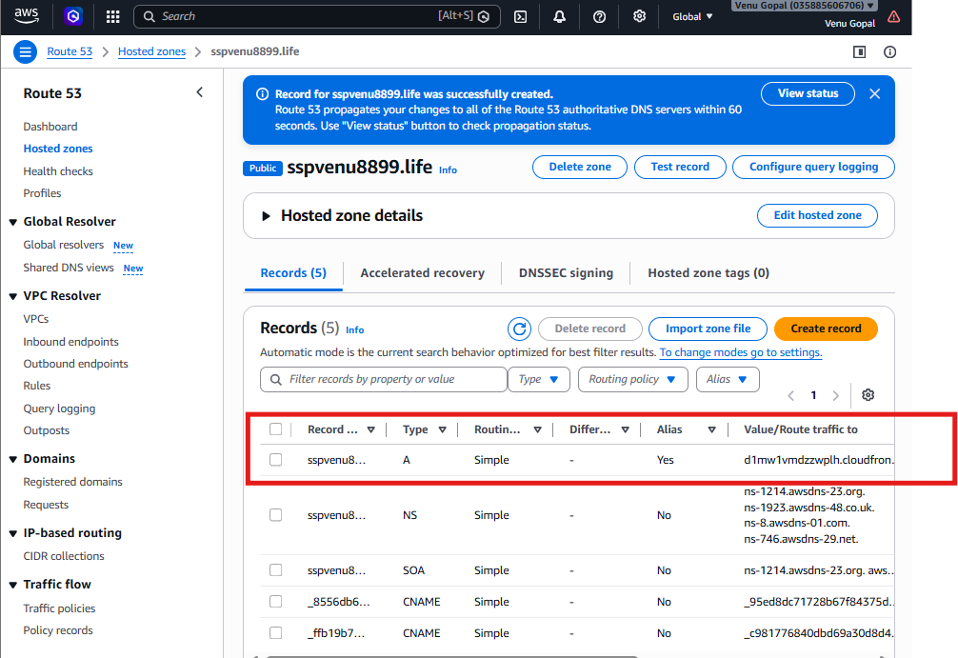

WWW Record (Optional)
Create another record:
Field | Value
Name | www
Type | A
Alias | Yes
Route Traffic To | Same CloudFront Distribution
Create Record.

Step 5: Configure Alternate Domain Name in CloudFront
Open
CloudFront → Your Distribution → General → Edit
Under
Alternate Domain Names (CNAMEs)
Add:
sspvenu8899.life
www.sspvenu8899.life
Then attach an ACM SSL certificate (in the us-east-1 / N. Virginia region) that covers:
- sspvenu8899.life
- www.sspvenu8899.life
Save the changes and wait for the distribution to deploy.
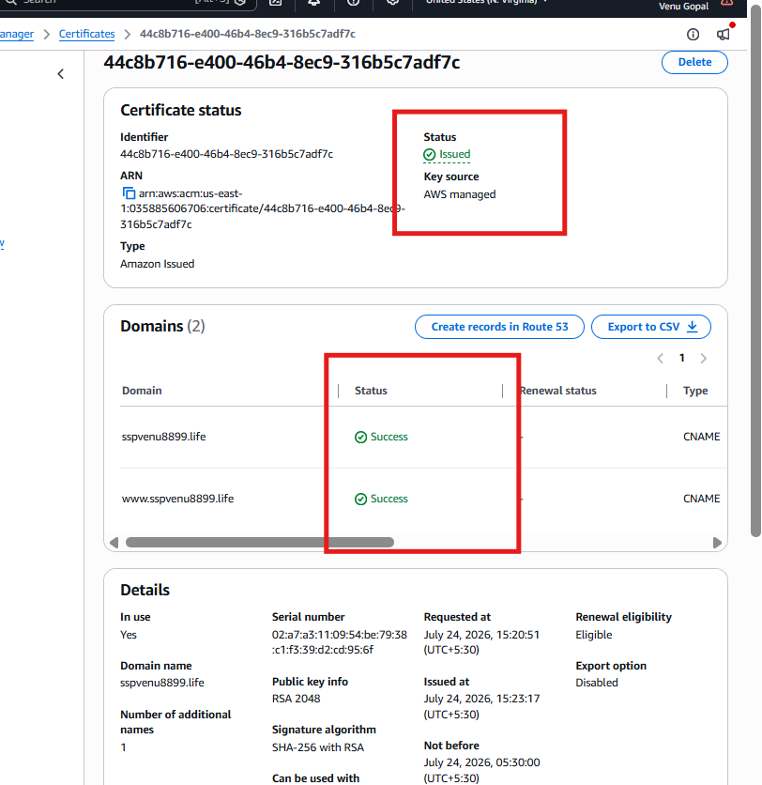

Step 6: Verify
Open:
https://sspvenu8899.life
It should load your CloudFront content.

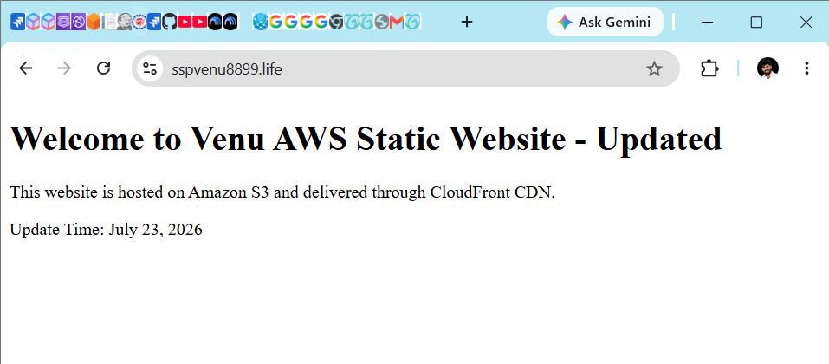

Task 7 — Share the domain name in Slack to test the connectivity
Implementation:
https://sspvenu8899.life
Output:
Welcome to Venu AWS Static Website - Updated

This website is hosted on Amazon S3 and delivered through CloudFront CDN.

Update Time: July 23, 2026

